# Space Shooter Part 2

## Content

* Import the two new sprites ammo and health

## New Tags

Add two new tags to the project:

* Ammo
* Health

We will use these tags to identify what type of pick up the player has collected.

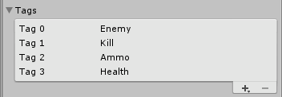

## Pickup Controller

* Crete a new Script called PickupController
* Both the Ammo and Health pickups will use this script
  + When the player collides with a pickup we want to get the value stored in the amount variable
  + If the pickup was health, then add the amount to the players health
  + If the pickup was ammo, then add the amount to the players ammo

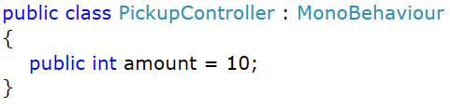

## Health PIckup



* Create a new GameObject called health
* Assign it the Health tag
* Add the pickup controller to this object
* Set the amount to be 5
* Add a BoxCollider2D
* Add a RigidBody2D
  + Mass = 0.01
  + Gravity Scale = 0

## Ammo Pickup

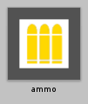

* Create a new GameObject called ammo
* Assign it the Ammo tag
* Add the pickup controller to this object
* Set the amount to be 5
* Add a BoxCollider2D
* Add a RigidBody2D
  + Mass = 0.01
  + Gravity Scale = 0

## Extending Player Controller

### Ammo Tracking

* Add a new variable to the player controller to track the amount of ammo we have



### Ammo Pickup Collision

* Add the following code after the collision check with an Enemy
* This should be in the OnCollisionEnter2D

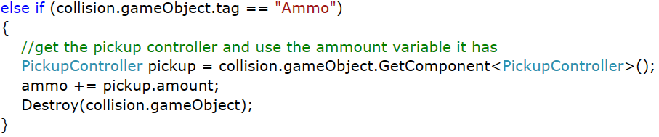

### Health Pickup Collision

* Add the following code after the collision check with an Ammo Pickup
* This should be in the OnCollisionEnter2D

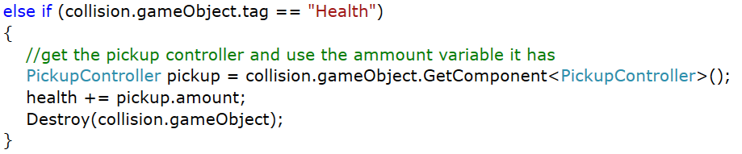

## Bullet Controller – SPawning Pickups

### Variables

* Add two new variables to the BulletController
* These will hold the two types of pickups that can be spawned

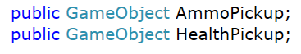

### Collision with Enemy

* Add the following code to the IF block that checks if the bullet collided with an Enemy
  + This should be in the OnCollisionEnter2D
* This code will pick a random number between 1 and 10
  + If the number is Even, then spawn an ammo pickup
  + If the number if Odd, then spawn a health pickup

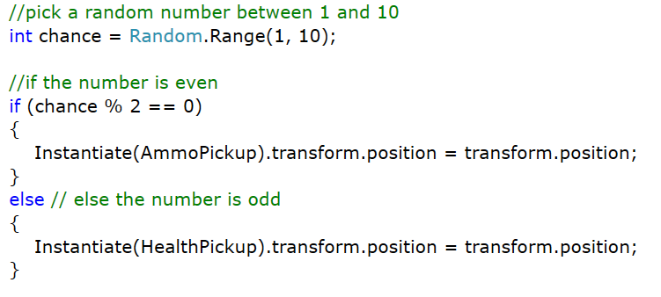

## Additonal Tasks (**20% Assignment Marks**)

1. **Using Random.Range(min, max) pick a random value between 5 and 25 for the damage value in the Enemy Controller**
   * Hint: Your code should be in the Start method to this
2. **Make the pickups fall down the screen**
   * Pickups should slowly move down the screen at a speed of -2
   * Hint: Look at EnemyController
3. **If the player has no ammo then they cannot fire new bullets**
   * If player ammo > 0
   * Needs to enclose the Instantiate(bullet) code
4. **Destroy the pickups if the hit a barrier**
   * If a pickup hits a barrier (Tag of Kill) then it should destroy itself
   * Hint: OnCollisionEnter2D of the PickupController
5. **Count the number of enemies destroyed**
   * Hint: use a static variable on the PlayerController to track the enemies killed
   * When a bullet destroys an enemy add one to the variable on the player
   * Hint: Look at Breakout PlayerController